FULL-TIME EDUCATION: THE ROLE OF THE SCHOOL IN THE FORMATION OF THE CITIZEN


https://doi.org/10.56238/arev6n4-346

Submitted on: 20/11/2024
Publication date: 20/12/2024

José Luiz Alves, Ismael dos Santos Oliveira, Maria Cleonice Santos de Melo Penha, Joseane Nascimento Lima da Silva Angelo and Caíque Alves Rocha Dutra

ABSTRACT
The study investigated the transformations in the educational field, covering from traditional practices to active methodologies aimed at promoting citizenship. The objective was to identify effective pedagogical strategies in the formation of critical and participatory citizens. The bibliographic research, carried out according to Fonseca (2002), was based on the survey and analysis of theoretical references published in written and electronic media, allowing a critical synthesis on the subject. The analysis was structured in five main parts: integral education as a tool of citizenship, the principles of integral and global student formation, transformations in the traditional educational model, active methodologies applied to the promotion of citizenship and the results observed. The findings highlighted that active methodologies transform the school environment by placing the student as the protagonist and integrating values of inclusion and cooperation. Despite this, challenges such as the need for infrastructure and the continuing education of teachers remain barriers to the full implementation of these practices. It was concluded that integral education, when associated with innovative practices and the use of technologies, plays an essential role in building a more equitable and citizen society, encouraging new research to explore complementary approaches.

Keywords: Inclusion, Cooperation, Transformation, Methodologies, Citizenship.
INTRODUCTION
The debate on integral education and its implications for the formation of citizenship has acquired increasing relevance, especially in a scenario where society demands more conscious, critical and participatory citizens. Education, as an instrument of social transformation, has been widely discussed, highlighting the importance of integrating values, practices and methodologies that encourage inclusion, cooperation and student protagonism. In this context, questions arise about how pedagogical approaches can contribute to forming citizens who are more prepared for contemporary challenges.
The objective of this study was to investigate the transformations that have occurred in the educational field, addressing from the traditional model to practices that use active methodologies to promote citizenship. The guiding question involved identifying 'which pedagogical strategies are most effective to strengthen citizenship in the school environment?' To this end, a bibliographic research was carried out, according to Fonseca (2002, n.p.), who defines this approach as "[...] carried out from the survey of theoretical references already analyzed and published by written and electronic means". The analysis technique used involved the critical synthesis of selected contents, prioritizing the identification of convergences and divergences in the theoretical frameworks.
Data were collected from academic sources and reports of practical experiences, structuring the analysis into five main parts. The first section, entitled 'Integral Education as a Tool for the Formation of Citizenship', discussed the relevance of an educational model that encompasses all dimensions of human development. Then, in 'Principles of Integral and Global Student Education', the fundamentals that guide a more inclusive and collaborative education were highlighted. The third part, 'Transformations in School: From a Traditional Model to the Promotion of Citizenship', analyzed the impact of pedagogical changes on the role of the teacher and students. In 'Promoting Citizenship with Active Methodologies', practical experiences that connect academic knowledge to citizenship values were addressed. Finally, in 'Results and Discussion', the impacts and challenges identified throughout the research were presented.
Therefore, the analysis revealed that integral education, combined with active methodologies, is a powerful tool for the promotion of citizenship, as long as structural and pedagogical challenges are overcome. Thus, new research is encouraged to explore complementary approaches, expanding the possibilities of a transformative and meaningful education.
INTEGRAL EDUCATION AS A TOOL FOR THE FORMATION OF CITIZENSHIP
Citizenship is a widely used concept, but it presents difficulties in measuring and operationalizing due to its complex and multidimensional nature (Caldas; Cavalcante, 2023). In this context, discussing citizenship requires considering both its material and symbolic aspects, as well as its concrete manifestations in different historical situations. Andrenacci (2019) highlights that citizenship in Latin America, in particular, should be understood as a status that varies according to historical and social circumstances, revealing the importance of the context for understanding this concept.
Thus, considering that rights emerge as demands of specific groups to promote conditions of equality (Dagnino, 2004), it is necessary to reflect on how educational institutions contribute to the formation of citizens. In this sense, full-time education emerges as a relevant model, since it extends the school time of students and offers conditions for human development in its various dimensions: intellectual, physical, affective, social and cultural. Consequently, the school is configured as a privileged space for the construction of citizenship, not only as a transmitter of academic content, but also as a promoter of values and skills necessary for life in society.
In accordance with Andrenacci (2019), who emphasizes the historical character of citizenship, full-time education allows pedagogical practices to be adapted to the demands of each historical and cultural context. This flexibility is essential for the school to meet the needs of students' citizenship education, creating conditions for individuals to understand their role as transforming agents in society. Furthermore, as pointed out by Dagnino (2004), integral education can act as a mediator of social claims, fostering in students the ability to fight for rights and build a more equitable society.
Also from this perspective, Caldas and Cavalcante (2023) reinforce the idea that the complexity of citizenship requires an educational approach that integrates several areas of knowledge. In this context, the full-time education model is capable of promoting interdisciplinary activities that articulate academic knowledge with practical experiences, contributing to a more effective citizenship education. Such practices are essential for students to develop skills that go beyond the school environment, becoming individuals engaged in social transformation.
Therefore, it is possible to conclude that full-time education presents itself as a powerful tool for the promotion of citizenship. Dialoguing with the theoretical references presented, it is perceived that this educational model not only extends the students' time in school, but also enhances the role of education in the formation of individuals capable of acting critically in their communities. In this way, the importance of a comprehensive education that promotes the full development of students and enables them to face the challenges of contemporary society is reaffirmed.

PRINCIPLES OF INTEGRAL AND GLOBAL STUDENT EDUCATION
The integral and global education of the student is based on essential principles that guide educational practice: student centrality, permanent learning, inclusive perspective and democratic management. Such foundations not only ensure quality education, but also promote the development of citizens prepared for contemporary challenges.
According to Marques et al. (2021, p. 724), "active methodologies are seen as great opportunities for creating positive learning outcomes", highlighting the centrality of the student in the educational process. In this context, the teacher must act as a mediator and facilitator, encouraging the learner's autonomy (Cunha et al., 2024. A practical example of this approach is the use of the flipped classroom, in which students research in advance the topics to be discussed and the teacher guides the reflections and deepening during the class. This methodology reinforces the student's responsibility for their learning, fostering skills such as critical analysis and problem solving.
Another relevant principle is lifelong learning, essential for the formation of individuals able to adapt to the constant changes in the modern world. As Marques et al. (2021, p. 724), "the benefits of active methodologies reflect an advance in the education of students, by encouraging autonomy and creativity". One practice that exemplifies this principle is the development of interdisciplinary projects that address real problems, such as creating sustainable solutions to environmental challenges, promoting collaborative learning and innovative thinking.
The inclusive perspective also plays a crucial role in comprehensive education, ensuring that all students have access to meaningful educational opportunities. In this context, Cunha et al. (2024) highlight the importance of teachers adapting their pedagogical practices to the needs of students, considering their specificities. For example, the use of assistive technologies, such as reading software for visually impaired students, is an effective tool for ensuring equitable participation in school activities.
Finally, democratic management promotes a school environment in which all actors — students, teachers and the community — contribute to the collective construction of the educational process. As Marques et al. (2021, p. 724), this approach encourages co-responsibility and engagement of participants. A viable practice is the creation of school councils, where representatives of different segments of the school community discuss and decide on pedagogical and administrative guidelines.

Table 1: Principles of Integral Education and Practical Examples
Principle | Definition | Practical Example
Student Centrality | Focus on the student as the protagonist of learning | Flipped classroom with research and mediated discussions
Lifelong Learning | Continuous skills development | Interdisciplinary projects, such as sustainable solutions to environmental problems
Inclusive Perspective | Accessible and meaningful education for all | Use of assistive technologies, such as reading software for visually impaired students
Democratic Management | Collective participation in school decision-making | Creation of school councils with representation from the community, students and teachers
Source: prepared by the authors.

Therefore, by articulating principles such as student centricity, lifelong learning, inclusive perspective, and democratic management, integral education is consolidated as a transformative tool. In this way, the development of individuals fully capable of acting in a meaningful way in contemporary society is promoted.

TRANSFORMATIONS IN SCHOOL: FROM A TRADITIONAL MODEL TO THE PROMOTION OF CITIZENSHIP
The transformations in the school environment reflect the advancement of pedagogical practices, which have gone from a traditional model to a focus focused on the promotion of citizenship and student protagonism. According to Silva (2018, p. 35), "active learning methodologies are based on the construction of knowledge and consequently learning, by the student himself, who is, therefore, his greatest agent". This perspective highlights the evolution of the school as a space for the transmission of information to a place of collaborative and reflective construction of knowledge.
In addition, the integration of collaborative practices and the use of Digital Information and Communication Technologies (DICTs) become indispensable elements in the student's citizenship education. According to Santana et al. (2021, p. 2096), "DICTs are seen as indispensable tools to serve the student of the twenty-first century". The use of digital platforms not only enhances learning, but also expands the possibilities of interaction, autonomy and school inclusion. For example, the implementation of virtual simulators in subjects such as science and mathematics allows for a more concrete and meaningful learning experience.
In the traditional model, education was centered on the teacher, who played the role of the sole holder of knowledge. This dynamic limited the active participation of students, resulting in a fragmented teaching-learning process. However, with the introduction of active methodologies, a significant reconfiguration is observed. According to Cunha et al. (2024), "the flipped classroom is a widely used strategy, especially in disciplines that require practical interaction". This methodology exemplifies how student centricity can be implemented by providing moments of prior research and collaborative discussions.
The image below clearly illustrates this transition. On the left side, the traditional model is represented, with the teacher in the center, explaining concepts on a board while the students, arranged in rows, use only paper, notebooks and books to record the content. On the right side, there is an environment of active methodologies, where students are in collaborative groups, using laptops and tablets to develop projects and solve problems autonomously, while the teacher assumes a role of facilitator, not centralizing the teaching process. This visual representation reinforces the fundamental differences between the two models and the positive impact of active methodologies on student engagement and autonomy.

Image 1 - Traditional x New
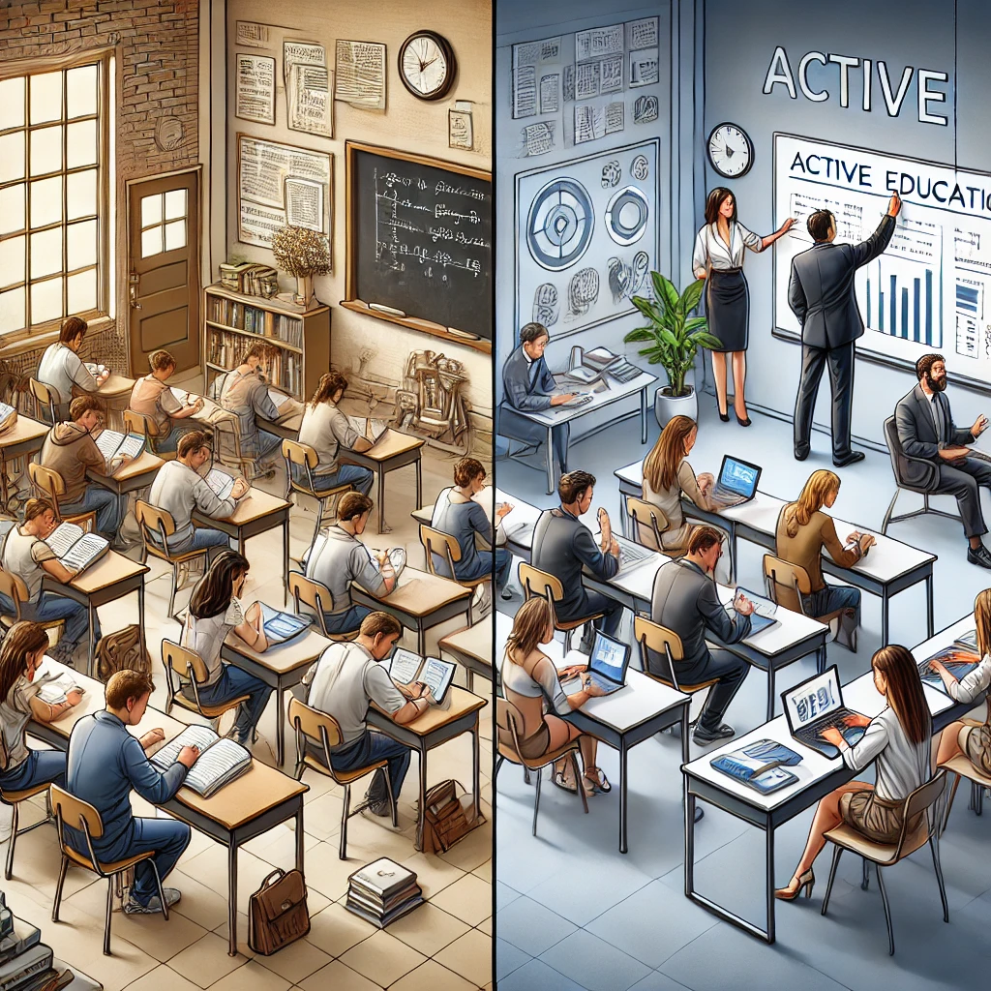
Source: AI-generated.

Also in this context, the importance of family involvement in the educational process is highlighted, an aspect that has shown positive impacts. According to Gomes and Nogueira (2017, p. 445), "the participation of the family in the school life of the children has had a positive impact in several areas". A practical example of this participation is the organization of joint pedagogical workshops between parents and students, aimed at the development of social and cognitive skills. These activities reinforce the ties between school and community, consolidating the role of education as a promoter of citizenship.
On the other hand, the search for inclusion also represents a fundamental pillar in contemporary education. Santana et al. (2021, p. 2087) emphasize that "not only the most needy, but also those responsible for people with disabilities have long fought for an optional educational modality that facilitates, which allows them to fight for equity". The implementation of resources such as access ramps, sign language translators and adapted pedagogical materials represents significant advances towards a truly inclusive education.
Thus, it is evident that the contemporary school is increasingly distancing itself from the traditional model and moving towards a pedagogical practice centered on student protagonism and inclusion. Based on the references presented, it is concluded that the transformations in educational practices promote not only academic learning, but also citizenship formation, essential for the challenges of today's society.

PROMOTING CITIZENSHIP WITH ACTIVE METHODOLOGIES
Active methodologies, when aligned with citizenship and cooperation projects, represent a powerful pedagogical approach to form more aware, supportive and engaged citizens. A striking example of this practice is the 'A União Faz a Vida' Program, developed by the Sicredi Foundation and implemented at the João Batista de Mello Municipal Elementary School, in Forquetinha, since 2022. This program uses project pedagogy to connect different areas of knowledge and foster student protagonism.
The initiative promotes the exploration of investigative themes that challenge students to question, reflect and create solutions, transforming the learning process into a meaningful experience. In this sense, education is no longer a simple transfer of content to become an experience that integrates values of cooperation and citizenship. Advisor Elisabete Penz Beuren highlighted that the commitment of teachers and the management team has been fundamental to engage the school community in a more transformative education.
The main objective of the program is to form fair, supportive and entrepreneurial citizens, encouraging respect for diversity and collaborative decision-making. Through a methodology that transforms students into protagonists, it is possible to promote citizen attitudes that go beyond the school environment. For example, projects such as the development of community gardens or environmental awareness campaigns allow students to experience the values discussed in the classroom in practice, strengthening their understanding of the role of citizens in society.
Principal Mirna Schmitz reinforced that the dedication of teachers to integrate these values into the school routine is essential for educational transformation. These projects not only encourage creative problem-solving, but also encourage teamwork and respect for differences, indispensable skills for citizenship formation.
Another relevant aspect of the program is the emphasis on collaborative decision-making. Through activities that involve debates, voting, and group discussions, students learn to consider different perspectives and value collective work. Such practices promote a broader understanding of democracy and inclusion, preparing students to act in a plural and diverse society.
For example, a common activity is the creation of a collective project that aims to solve problems identified in the local community. This approach not only develops cognitive and social skills, but also reinforces the idea that learning should be connected to reality and lived experience.
The impact of active methodologies, associated with project pedagogy, is visible not only in academic development, but also in the formation of values that shape coexistence and citizenship. In Forquetinha, the program's projects have transformed both the school and the community, strengthening the bonds between educators, students and families.
These experiences highlight the relevance of investing in methodologies that connect academic knowledge to citizen practice, encouraging the construction of a more equitable and cooperative society. By promoting citizenship with active methodologies, it is demonstrated that education can be a powerful agent of social transformation.

RESULTS AND DATA ANALYSIS
The main objective of this bibliographic research was to investigate the transformations in education, from the traditional model to the adoption of inclusive and student-centered pedagogical practices. Works that address the use of active methodologies, Digital Information and Communication Technologies (DICTs) and the impact of family participation and inclusion in citizenship education were selected.
According to Silva (2018), active methodologies promote a significant change by placing the student at the center of the learning process. This approach resignifies the role of the teacher, who starts to act as a mediator. However, gaps were identified with regard to the continuing education of teachers to implement these practices. Santana et al. (2021) highlight that, although DICTs are essential tools, the lack of infrastructure in many schools represents a significant barrier.
On the other hand, Gomes and Nogueira (2017) emphasize the participation of the family in the educational process, but point out that there are challenges in engaging parents from more vulnerable communities. Inclusion is also widely discussed, especially by Santana et al. (2021), which highlight the need for resources and adaptations to ensure equity in access to education.

COMPARING PERSPECTIVES
When comparing the authors, it is observed that there is consensus on the importance of pedagogical transformations. Silva (2018) and Cunha et al. (2024) agree that active methodologies are effective in promoting students' autonomy and creativity, but Cunha et al. They point out that the flipped classroom demands a high level of student engagement and technological support. In turn, Moraes and Santos (2023) highlight digital culture as a tool for inclusion and empowerment, but warn of the risk that it will become exclusionary in contexts of inequality.
Regarding inclusion, Santana et al. (2021) and Narciso et al. (2024) reinforce the relevance of DICTs, especially for students on the autism spectrum, showing that these technologies expand educational reach and enable more meaningful interactions. However, both studies point out that there are structural challenges that need to be overcome.

PRACTICAL EXAMPLES
To exemplify, a reported practice was the use of virtual simulators in subjects such as mathematics, allowing students to explore complex concepts in an interactive way (Santana et al., 2021). In addition, pedagogical workshops involving parents and students have been shown to be effective in strengthening the ties between school and community (Gomes; Nogueira, 2017). Another significant experience was the use of Libras translators and adapted materials to promote the inclusion of students with hearing impairment (Santana et al., 2021).

SUMMARY AND CONCLUSION
Based on the evidence analyzed, it is concluded that the educational transformations discussed contribute significantly to the promotion of citizenship and inclusion. However, the absence of adequate infrastructure and the need for continuing education of teachers are still challenges that need to be overcome. To move forward, it is essential to invest in technological resources and the active participation of the school community, promoting education that is accessible, inclusive, and transformative.

CONCLUSION
The present research sought to analyze the transformations in the educational field, from traditional practices to innovative and inclusive approaches, focusing on the student's protagonism, the use of Digital Information and Communication Technologies (DICTs) and the relevance of family participation in the pedagogical process. The study achieved its objectives by identifying and discussing the main strategies that promote citizenship and inclusion in the school environment, showing how the transition between traditional pedagogical models and active methodologies contributes to a more dynamic and effective teaching.
Throughout the analysis, it became evident that the role of the teacher, although resignified, continues to be essential as a mediator of the learning process. The centrality of the student, promoted by active methodologies, represents a significant advance in the search for a more participatory and reflective education. In addition, the use of DICTs was widely recognized as an indispensable tool for the democratization of access to knowledge and for overcoming barriers imposed by structural inequalities. However, gaps were identified, such as the need for adequate infrastructure and the continuing education of teachers, which still limit the full implementation of these strategies.
The research also highlighted the importance of family involvement as a transforming agent in the educational process. This aspect reinforces that education is not an exclusive responsibility of the school, but a joint construction that requires the engagement of the entire community. Practical experiences, such as pedagogical workshops and inclusion programs, illustrated the benefits of collaborative actions in promoting a more equitable and inclusive education.
Thus, the transformations discussed in this study demonstrate that the strengthening of citizenship and inclusion in the school environment depends on continuous efforts to integrate new technologies, promote active methodologies and engage the different actors in the educational process. More research is encouraged to explore other approaches that leverage these advances and expand the possibilities of a truly transformative, accessible, and meaningful education for all students.

REFERENCES

1. Andrenacci, L. E. (2019). Um ensaio sobre a história da cidadania na América Latina a partir de uma perspectiva de longo prazo. Cadernos EBAPE.BR. Disponível em: https://periodicos.fgv.br/cadernosebape/article/view/74321. Acesso em: 09 dez. 2024.

2. Caldas, P. T., & Cavalcante, C. E. (2023). Praticando a cidadania: Criação e validação de uma escala de mensuração. Cadernos EBAPE.BR, 21(4). DOI: https://doi.org/10.1590/1679-395120220132. Acesso em: 09 dez. 2024.

3. Cunha, M. B. da, Omachi, N. A., Ritter, O. M. S., Nascimento, J. E. do, Marques, G. de Q., & Lima, F. O. (2024). Metodologias ativas: Em busca de uma caracterização e definição. Educação e Realidade, 40. Disponível em: https://doi.org/10.1590/0102-469839442. Acesso em: 07 dez. 2024.

4. Dagnino, E. (2004). Construção democrática, neoliberalismo e participação: Os dilemas da confluência perversa. Revista de Ciências Sociais, 3(5). DOI: https://doi.org/10.5007/%25x. Acesso em: 09 dez. 2024.

5. Fonseca, J. J. S. (2002). Metodologia da pesquisa científica. Fortaleza: UEC.

6. Gomes, C., & Nogueira, L. S. (2017). A influência da família na formação educacional: Uma análise sobre a importância do apoio parental. Revista Brasileira de Educação, 22(69), 442-457. Disponível em: https://doi.org/10.1590/S1413-24782017226936. Acesso em: 02 dez. 2024.

7. Marques, H. R., Campos, A. C., Andrade, D. M., & Zambalde, A. L. (2021). Inovação no ensino: Uma revisão sistemática das metodologias ativas de ensino-aprendizagem. Avaliação (Campinas), 26(3), set.-dez. Disponível em: https://doi.org/10.1590/S1414-40772021000300005. Acesso em: 07 dez. 2024.

8. Moraes, G. L. de, & Santos, G. M. dos. (2023). A educação em tempos de cultura digital: Oportunidades e desafios. Revista Científica Multidisciplinar Núcleo do Conhecimento, 8(5), 75-90. ISSN: 2448-0959. Disponível em: https://www.nucleodoconhecimento.com.br/filosofia/tempos-de-cultura. DOI: 10.32749/nucleodoconhecimento.com.br/filosofia/tempos-de-cultura. Acesso em: 09 dez. 2024.

9. Narciso, R., Oliveira, F. C. N. de, Alves, D. de L., Duarte, E. D., Maia, M. A. dos S., & Rezende, G. U. de M. (2024). Inclusão escolar: Desafios e perspectivas para uma educação mais equitativa. Revista Ibero-Americana de Humanidades, Ciências e Educação, 10(8), 713–728. Disponível em: https://doi.org/10.51891/rease.v10i8.15074. Acesso em: 09 dez. 2024.

10. Santana, A. C. de A., Pinto, E. A., Meireles, M. L. B., Oliveira, M. de, Munhoz, R. F., & Guerra, R. S. (2021). Educação & TDIC’s: Democratização, inclusão digital e o exercício pleno da cidadania. Revista Ibero-Americana de Humanidades, Ciências e Educação, 7(10), 2084–2106. Disponível em: https://doi.org/10.51891/rease.v7i10.2748.
11. Silva, J. M. R. (2018). Utilizando as metodologias ativas de aprendizagem com sucesso (Monografia de Especialização em Educação: Métodos e Técnicas de Ensino). Universidade Tecnológica Federal do Paraná, Diretoria de Pesquisa e Pós-Graduação. Disponível em: https://repositorio.utfpr.edu.br/jspui/bitstream/1/21171/1/utilizandometodologiasativasaprendizagem.pdf. Acesso em: 09 dez. 2024.

Doctorate student in Educational Sciences Inter-American Faculty of Social Sciences (FICS) Email: escolareal21@gmail.com LATTES: http://lattes.cnpq.br/5994079679397853
Master in Emerging Technologies in Education MUST University E-mail: maestroismaelsantos@gmail.com LATTES: http://lattes.cnpq.br/6502792683207702
Master's student in Educational Sciences World University Ecumenical Email: maria.penha@prof.edu.natal.rn.gov.br LATTES: http://lattes.cnpq.br/4954858857849699
Linguistic Specialist Applied to Portuguese and English Language Teaching University of the State of Mato Grosso (UNEMAT) Email: joseaneangel123@gmail.com LATTES: http://lattes.cnpq.br/3150247217818850
Master's student in Emerging Technologies in Education Must University E-mail: caique.dutra@edu.mt.gov.br LATTES: https://lattes.cnpq.br/5271400260703139

