PREPARATION OF LOWER MOLAR WITH SEQUENCE MK LIFE FILE PATIENT WITH ASYMPTOMATIC IRREVERSIBLE PULPITIS

 | https://doi.org/10.56238/levv16n47-010

Submitted on: 03/04/2025
Publication date: 04/04/2025

Rosana Maria Coelho Travassos, Pedro Henrique Pereira de Souza, Josué Alves, Adriane Tenório Dourado Chaves, Priscila Prosini, Alexandre Batista Lopes do Nascimento, Ronaldo Carvalho Rsimundo, Verônica Maria de Sá Rodrigues, Mônica Maria de Albuquerque Pontes, Pedro Henrique de Barros Falcão, Priscylla Gonçalves Correia Leite de Marcelos

ABSTRACT
The objective of this study was to present a clinical case report of a patient in need of endodontic treatment in element 46, with asymptomatic irreversible pulpitis. A 36-year-old female patient sought care in a private office, reporting pain when biting. Radiography revealed atretic canals and coronary fracture with possible pulp exposure. The treatment was performed with special files from C-Pilot and Glide Path to obtain patency, and a mechanized rotary system, Sequence Rotary File from MK Life, 2.5% Sodium Hypochlorite as an irrigating solution and Sealer plus cement from MK Life as filling material. It is concluded that the Sequence Rotatory File (Mk life) instruments determine an adequate modeling of atretic root canals of the lower molar.

Keywords: Calcification of the Dental Pulp. Endodontics. Root Canal Preparation.

INTRODUCTION
The pulp and dentin comprise the biological unit, being known as the pulpo-dentin complex and throughout life the deposition of secondary and tertiary dentin occurs, reducing the size of the pulp chamber and its conduits (canal lumen) can occur in a total or partial way, being a challenge to locate and work in the canals. This condition of root canal atresia is not a contraindication for endodontic therapy, however additional attention is needed during clinical procedures. In the atretic canals there is a decrease in the volume of the pulp space. (SUAREZ; MILK; PAIVA, 2021).
The success of non-surgical endodontic treatment is based on cleaning, shaping and proper filling of the root canal. A complete instrumentation with abundant irrigation is the cornerstone for successful treatment. (Shaiban et al. 2023).
The great challenge in biomechanical preparation is the anatomical variation of root canals, especially atretic and curved, making it difficult to perform an ideal preparation. In order to overcome this challenge, nickel titanium (NiTi) alloys were introduced to the market, presenting more safety, high flexibility and resulting in better preparations and with few changes in the original anatomy of the canal (Machado et al., 2012). From the NiTi alloy, rotating instruments (continuous clockwise rotation of dentin cutting), driven by an electric motor, began to be used in order to ensure that the preparation of root canal systems occurs in a more controlled manner, especially in atretic and curved canals, allowing shorter work time, taper and low rates of irregularities (Vilas-Boas et al., 2013).
The knowledge of the internal anatomy of root canals is of fundamental importance for the success of the treatment, the chemical-mechanical preparation in many teeth is a great challenge, due to the great variety of size, shape and anatomical variations such as curvatures, atresias, ramifications and calcifications, among others. The mechanical action of instrumentation and irrigation are capable of substantially reducing the amount of microorganisms and degenerated tissue inside the root canal system (Campos, 2019).
Conventional endodontic treatment performed within technical standards is sufficient to determine the success of the therapy, allowing periapical repair, through effective cleaning and disinfection, and hermetic filling of the root canal system. (Travassos et al. 2025).
The objective of this study was to present a clinical case report of the preparation of lower molar with Sequence MK Life file.

CASE REPORT
patient in need of endodontic treatment in element 46, with asymptomatic irreversible pulpitis. A 36-year-old female patient sought care in a private office, reporting pain when biting. Radiography revealed atretic root canals and coronary fracture with possible pulp exposure. (Figure 1).

Figure 1 - Atresic root canals and coronary fracture with possible pulp exposure.
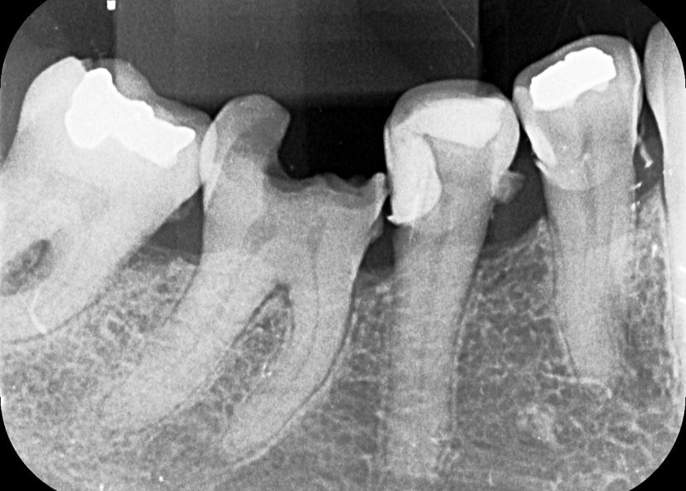

After truncal anesthesia with 1 tube of 2% mepivacaine with adrenaline vasoconstrictor in the proportion of 1:100,000 (DFL, Rio de Janeiro, Brazil), absolute isolation was performed on tooth 46 with metal clamp number 26 and rubber sheet (Easy/Bassi, Belo Horizonte-MG, Brazil), coronary opening was performed with spherical diamond tip 1014 (KG Sorensen, Cotia – SP, Brazil). After locating the root canal entrances with the straight probe, exploration with special files from C Pilot (VDW, Munich, Germany) numbers #06, #08, #10 and #15. The preparation was carried out with a Sequence MK Life Lima 35.04 file with an E-Connect Pro endodontic motor (Mk Life, Porto Alegre – RS, Brazil), after electronic dentistry, E-Pex Pro (Mk Life, Porto Alegre- RS, Brazil).
The filling technique was performed with a single gutta-percha cone (FR- EL Odous de Deus calibrado, Belo Horizonte-MG, Brazil) locked 1 mm below the actual length of the tooth (CRD – 1 mm), associated with Sealer Plus Cement (Mk Life, Porto Alegre-RS, Brazil). The tooth was provisionally restored with glass ionomer and the patient was referred to a dentistry clinic to make the definitive restoration of this dental element. (Figure 2).

Figure 2 – Filling of the root canal system by the single-cone technique associated with Sealer Plus.
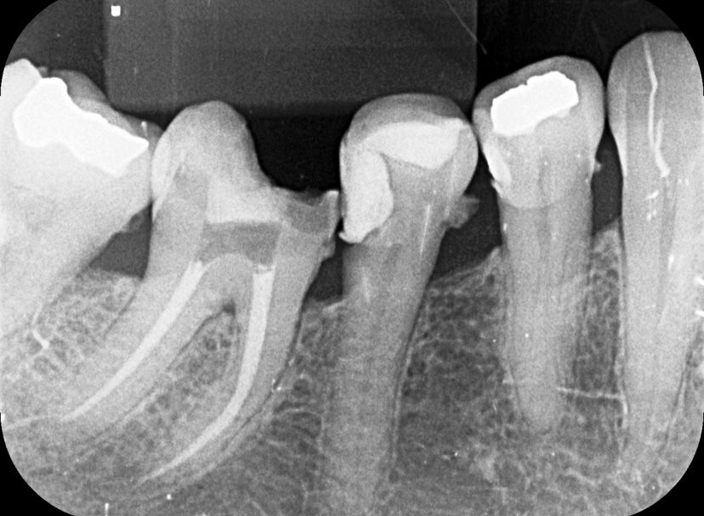

DISCUSSION
Most instrumentation techniques suggest that exploration or catheterization should be performed at the beginning of the chemical-mechanical preparation, this stage can be translated as the initial contact of the professional with the internal anatomy of the canals, through which it will be possible to predict the number, direction and diameter of the canals, as well as the possibility of access to the apical region. This goal is easily achieved in wide channels, which is not always the case when it comes to sassy channels. (MARTINS, DE FARIAS, DA SILVA, 2021).
The introduction of nickel-titanium (NiTi) mechanical instruments has drastically changed clinical endodontics in the last decades. Before NiTi, it was necessary to use more instruments to create an optimal root canal shape, and many approaches, sequences, and techniques have been developed over the years. Recently, NiTi endodontic instruments have undergone a series of changes brought about by design modifications, surface treatments, and heat treatments to improve their root canal preparation results. Heat treatment is one of the most fundamental approaches to improving the fatigue resistance and flexibility of NiTi endodontic instruments. In addition, new kinematics have been developed to offer greater safety and efficiency. (Grande et al. 2023)
The Sequence Mk Life File, also called SRF Sequence Rotary File, has surface heat treatment and high flexibility, and is designed to provide excellent strength and cutting power during endodontic procedures. These files showed good results throughout the treatment of this case because they have high flexibility, resistance and cutting power. In addition to having an inactive tip, maintaining the channel light and avoiding deviations. They have surface heat treatment and inactive tip to keep the channel light. In the present study, endodontic treatment was performed with the Sequence Rotary File System (SRF-MK life). These are files that receive heat treatment for NiTi alloys with memory control (CM). They are heated and cooled, thus resulting in the surface color corresponding to the thickness of the titanium oxide layer received. (Kim, Love, George et al., 2017). CM wired NiTi instruments offer improved performance and safety. Surface treatment makes the files more flexible, more fatigue-resistant, and efficient in cutting (Nogueira et al., 2020). In this study, files #15.04 (for the Glide-path) were used. Based on the present case report, it can be concluded that the performance of the Glide path has a relevant role in endodontic therapy, facilitating the biomechanical preparation as well as reducing the risks inherent to the root anatomy.
Irrigation is a key part of successful root canal treatment. It has several important functions, which may vary according to the irrigant used: it reduces friction between the instrument and the dentin, improves the effectiveness of cutting files, dissolves the tissue, cools the file and the tooth and, in addition, has a washing effect and an antimicrobial/antibiofilm effect. Irrigation is also the only way to impact the areas of the root canal wall not touched by mechanical instrumentation Sodium hypochlorite is recommended as the main irrigant since it has a broad spectrum of action and tissue dissolution capacity. In addition to these projected properties, the activation of the irrigating solution enhances the decontamination process of the root canal system. In this case, the Easy Clean plastic instrument was used, which has the function of performing the physical improvement of the irrigator, with greater penetrability in the lateral channels, isthmus and existing branches, maximizing cleaning and decontamination (Travassos et al. 2025).
The filling technique or the filling cement can have repercussions on the quality of the sealing and repair of periapical lesions. In the present clinical case, the single cone technique was chosen, added to Bio-C Sealer bioceramic cement due to its excellent biological and physicochemical properties. (Lopes, Siqueira Jr., 2010). This technique was used in the aforementioned clinical case, as it ends up becoming more effective, since instrumentation with rotary files provides the canal with a shape and conicity coinciding with the gutta-percha cone. The technique has some advantages over the lateral condensation technique, such as a shorter operating time and the possibility of having fewer empty spaces in the filling (SANTARÉM, 2016).

CONCLUSION
It is concluded that the Sequence Rotatory File (Mk life) instruments determine an adequate modeling of atretic root canals of the lower molar.

REFERENCES

- Campos, F. A. T., & et al. (2019). Sistemas rotatórios e reciprocantes na endodontia. Revista Campo do Saber, 4(5), 1–10.

- Grande, N. M., Castagnola, R., Minciacchi, I., Marigo, L., & Plotino, G. (2023). A review of the latest developments in rotary NiTi technology and root canal preparation. Australian Dental Journal, 68(1), 24–38. https://doi.org/10.1111/adj.12929

- Kim, Y., Love, R., & George, R. (2017). Surface changes of PathFile after glide path preparation: An ex vivo and in vivo study. Journal of Endodontics, 43(10), 1674–1678. https://doi.org/10.1016/j.joen.2017.05.014

- Lopes, H. P., & Siqueira Júnior, J. F. (2010). Endodontia: Biologia e técnica (3rd ed.). Guanabara Koogan.

- Machado, M. E. L., & et al. (2012). Análise do tempo de trabalho da instrumentação recíproca com lima única: Wave One e Reciproc. Revista da Associação Paulista de Cirurgiões Dentistas, 66(2), 120–125.

- Martins, D. F. O., de Farias, M. C. S., & da Silva, L. R. M. (2021). The glide path in contemporary endodontics: Literature review. ID on Line Revista de Psicologia, 15(58), 324–333. https://doi.org/10.14295/idonline.v15i58.3352

- Santarémm, F. T. R. (2016). Técnicas de obturação: Condensação lateral vs cone único [Doctoral dissertation, Instituto Superior de Ciências da Saúde Egas Moniz]. Repositório Egas Moniz. [Note: No URL provided; please provide if available]

- Shaiban, A. S. (2023). Healing of large through-and-through periapical lesion managed by non-surgical endodontic treatment. Journal of Health Sciences, 8(2), 146–148. https://doi.org/10.17532/jhs.2023.146 [Note: DOI assumed; please confirm]

- Suarez, A. V. G., Leite, A. R., & Paiva, S. S. M. (2021). Manobras para a localização de canais radiculares calcificados. Cadernos de Odontologia do UNIFESO, 3(1), 1–10.

- Travassos, R. M. C., & et al. (2025). Regressão total da radiotransparência óssea periapical do tratamento endodôntico do dente 11. Brazilian Journal of Implantology and Health Sciences, 7(3), 2013–2025. https://doi.org/10.36557/2674-8169.2025.7.3 [Note: DOI assumed; please confirm]

- Vilas-Boas, R. C., & et al. (2013). RECIPROC: Comparativo entre a cinemática reciprocante e rotatória em canais curvos. Revista Odontológica do Brasil Central, 22(63), 1–10.

Doctor University of Pernambuco, Brazil
General practitioner University of Nova Iguaçu - Campus V - Itaperuna RJ
Doctor University of Pernambuco, Brazil
Doctor University of Pernambuco, Brazil
Doctor University of Pernambuco, Brazil
Doctor University of Pernambuco, Brazil
Doctor University of Pernambuco, Brazil
Doctor University of Pernambuco, Brazil
Doctor University of Pernambuco, Brazil
Doctor University of Pernambuco, Brazil
Doctor University of Pernambuco, Brazil

